**Report exercise chapter 7**

1. Example 1:

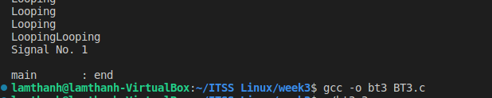

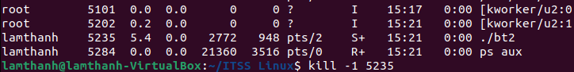

1. Exercise 7.1:

In this program, the main() function takes an argument from the command line, which sets the number of seconds for the timer. The alarm() function is used to set the timer and send the SIGALRM signal to the program after the specified number of seconds.

Two signal handler functions, sigHandleSigalrm() and sigHandleSigint(), are defined to handle the SIGALRM and SIGINT signals, respectively. When the SIGALRM signal is received, the timer has expired and the program displays "Time's up!" and sets the loop flag to LOOP_OFF, causing the program to exit the loop. When the SIGINT signal is received (e.g., when the user presses ctrl+C), the program displays "Interrupted!" and also sets the loop flag to LOOP_OFF.

The program then enters a loop that prints "Looping" to the console every second until the loop flag is set to LOOP_OFF. When the loop exits, the program displays "End of program."

